**Surabhi Asati**

**STAT – 6610**

**Homework assignment-3**

1. Show that you attempted all the Activities that were discussed in class during Week 5.

Activity 1:

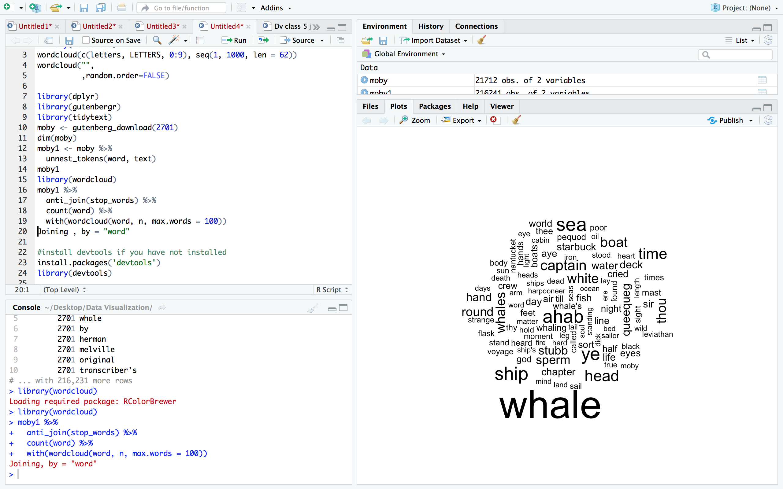

Activity 2:

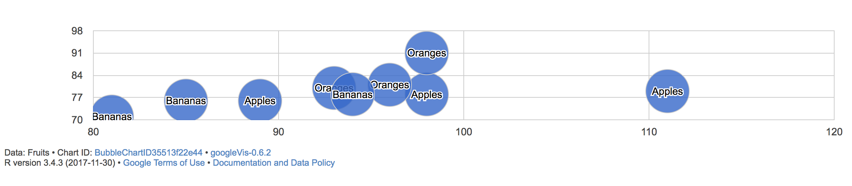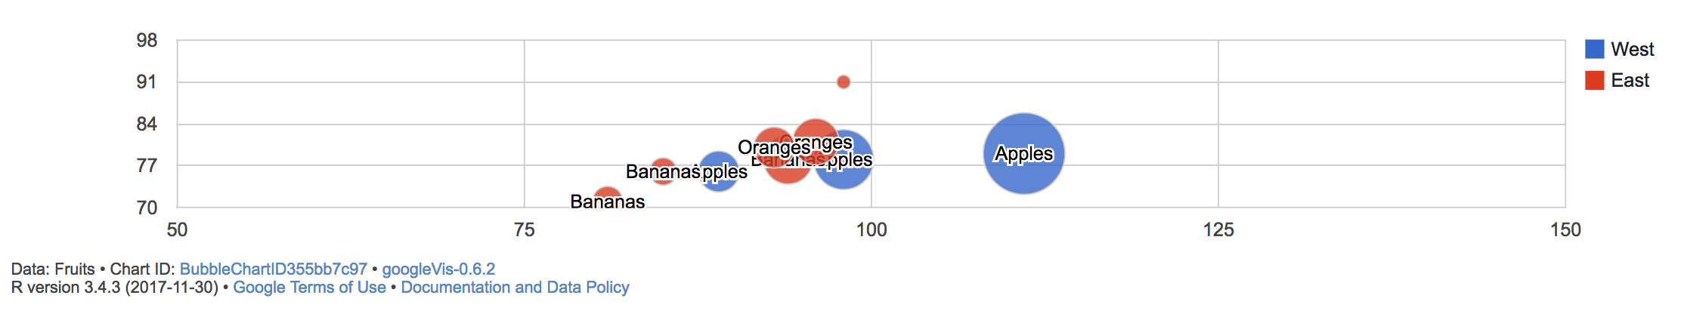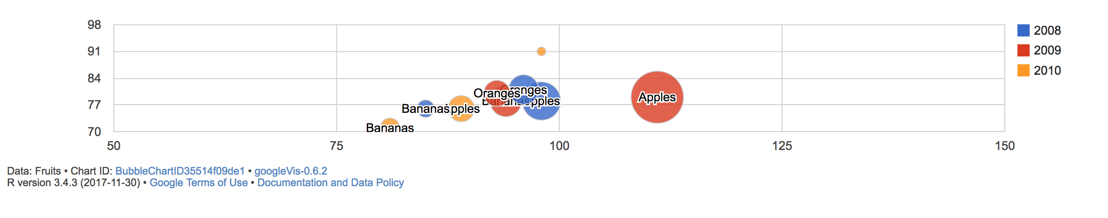

Activity 3:

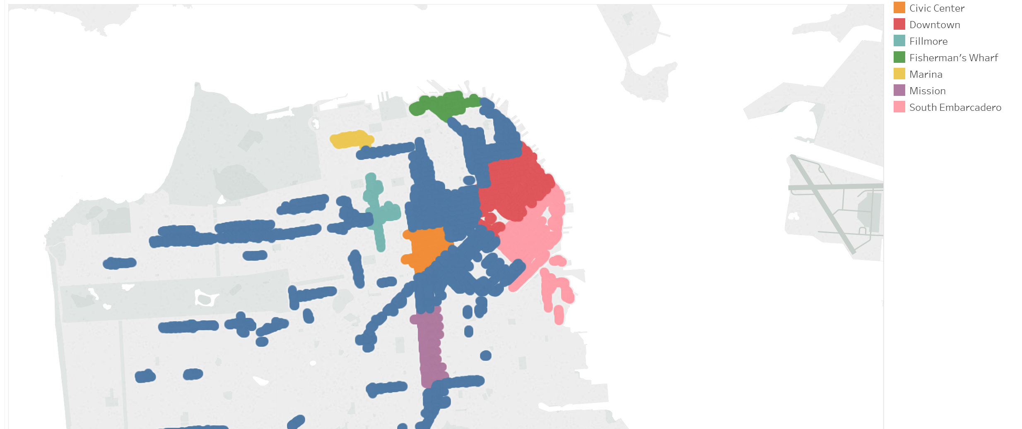

Activity 4:

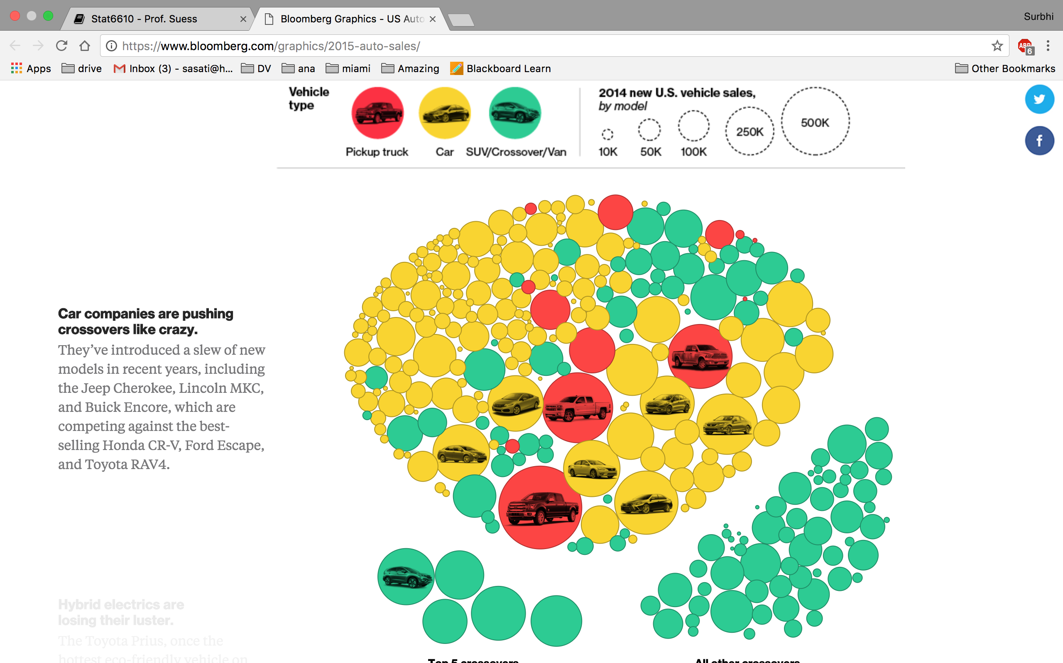

Activity 5: See question 4 below

Activity 6: See question 5 below

1. Make another wordcloud from Activity One. Find a different book/document to visualize.

Book: Pride and Prejudice -1342

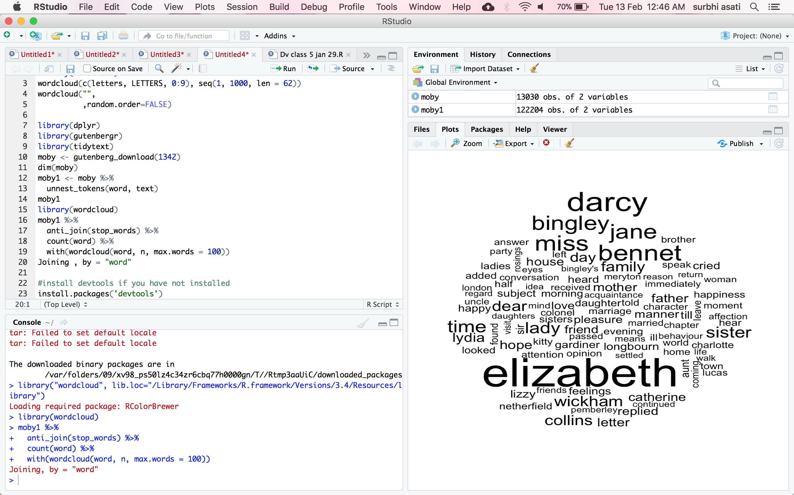

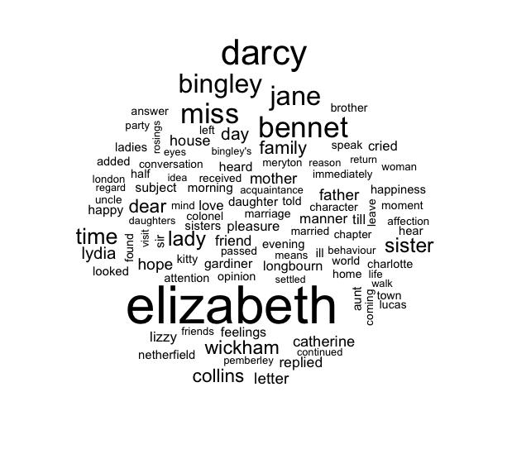

1. Make a different map from Activity Three.

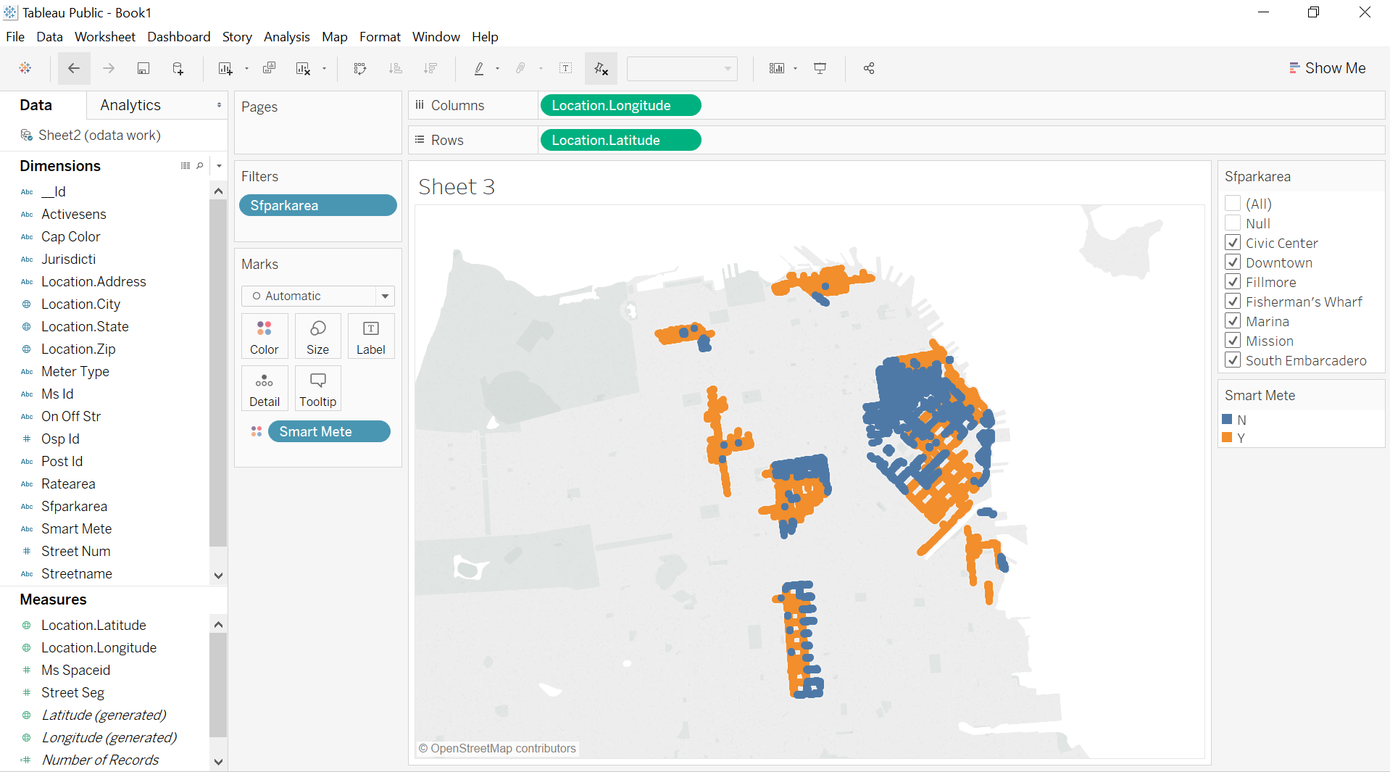

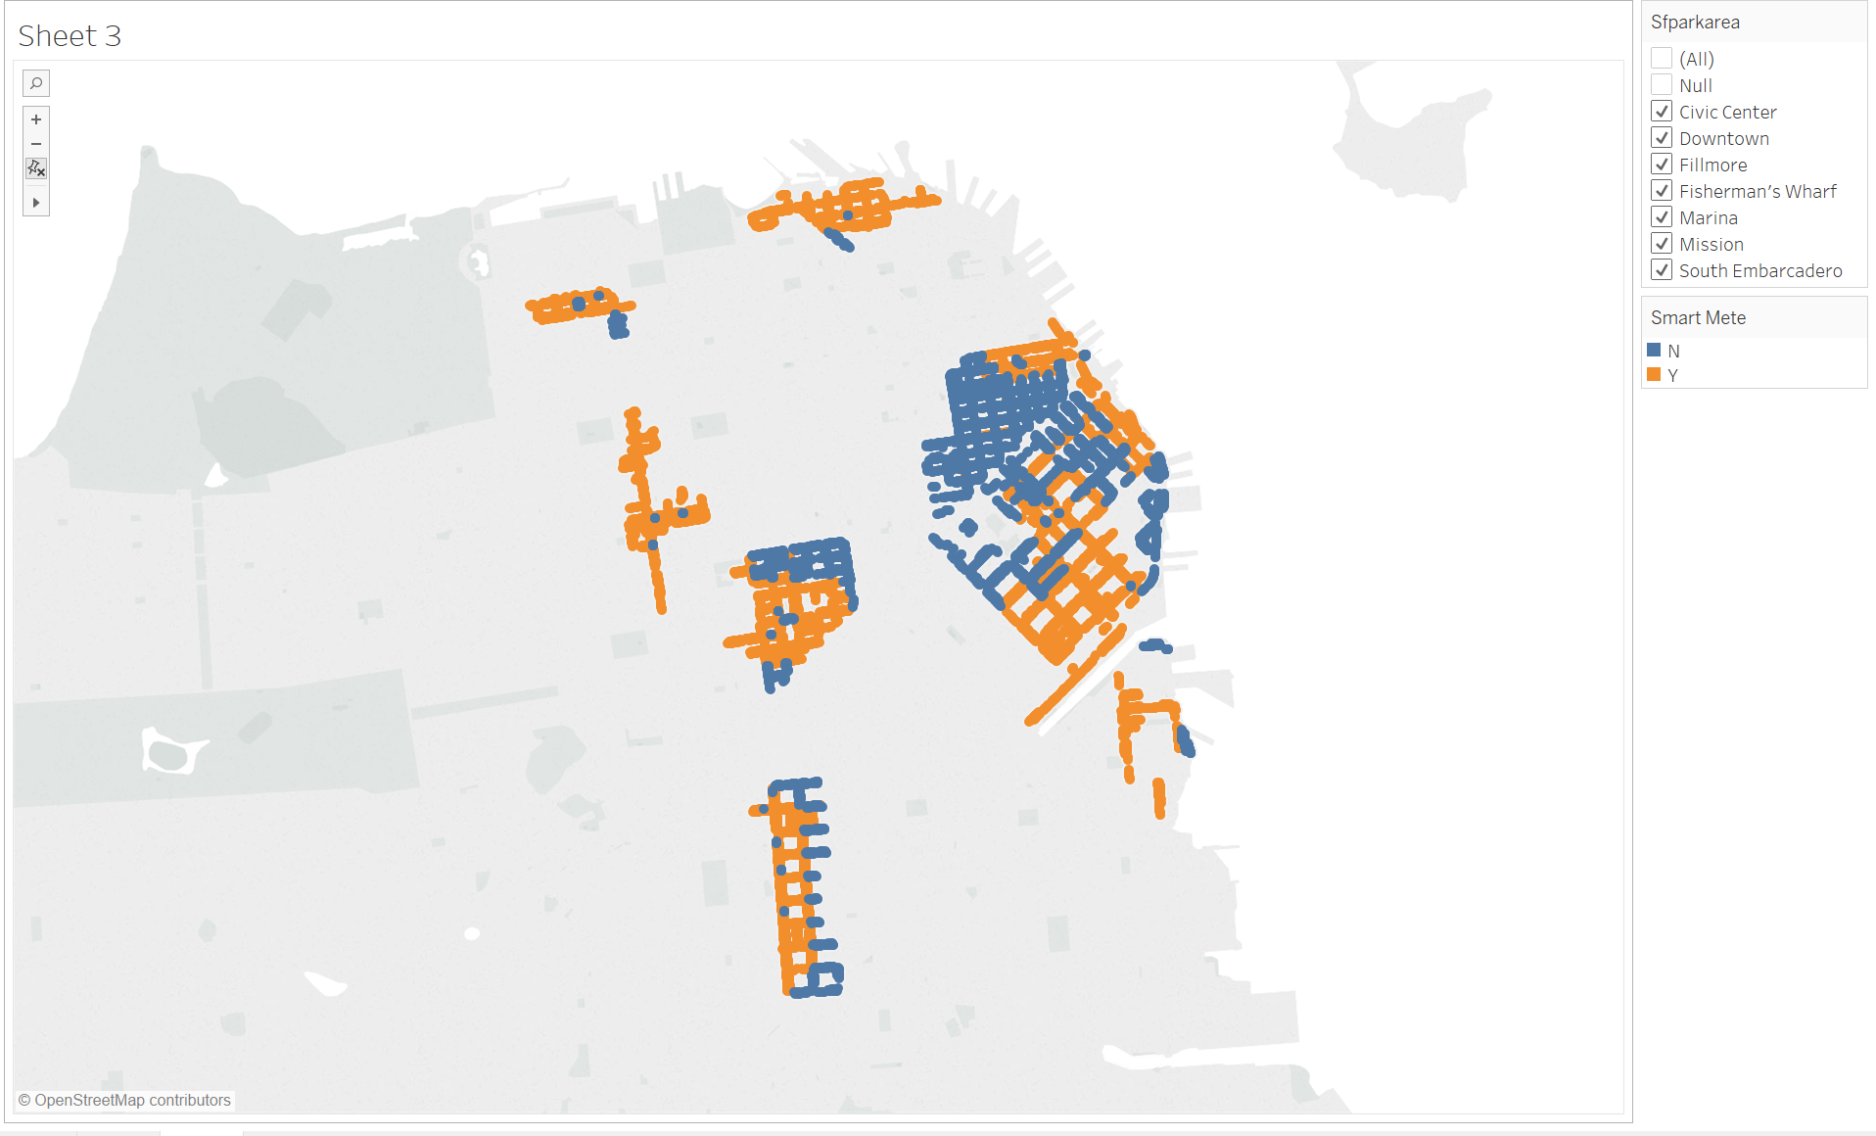

1. Make a candlestick chart in [plot.ly](https://plot.ly/) from Activity Five. Login into Plotly. Click on + Create button and select Dataset.  
   Click Upload, browse to where where finance data is. You can use your stock market data from yahoo finance.

Candlestick chart: Bitcoin

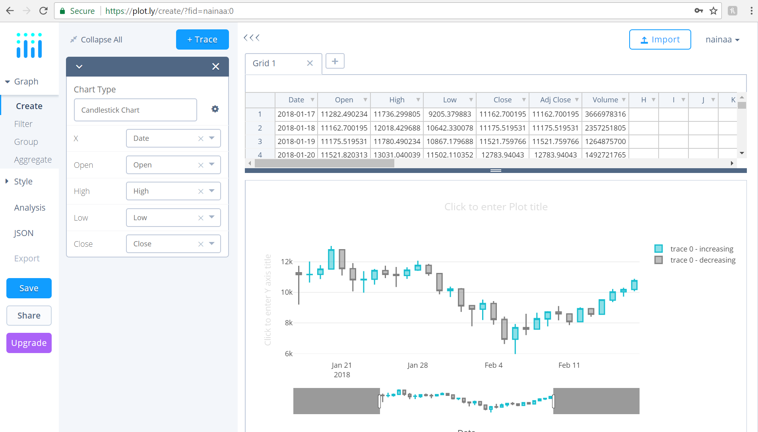

1. Make a map of the Bay Area from Activity Six.

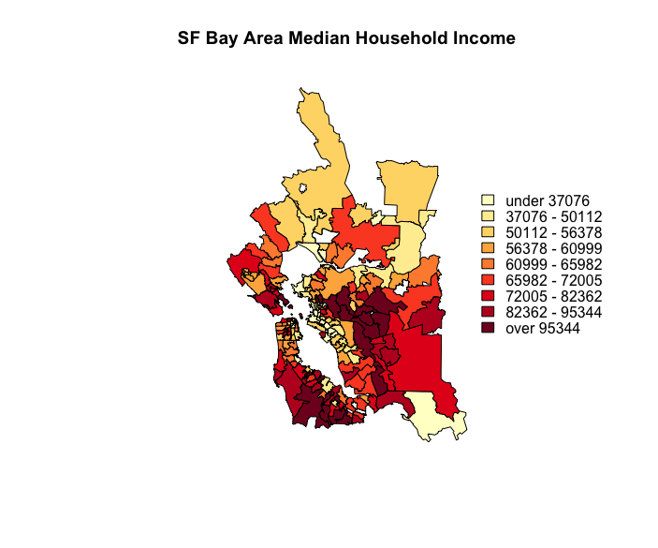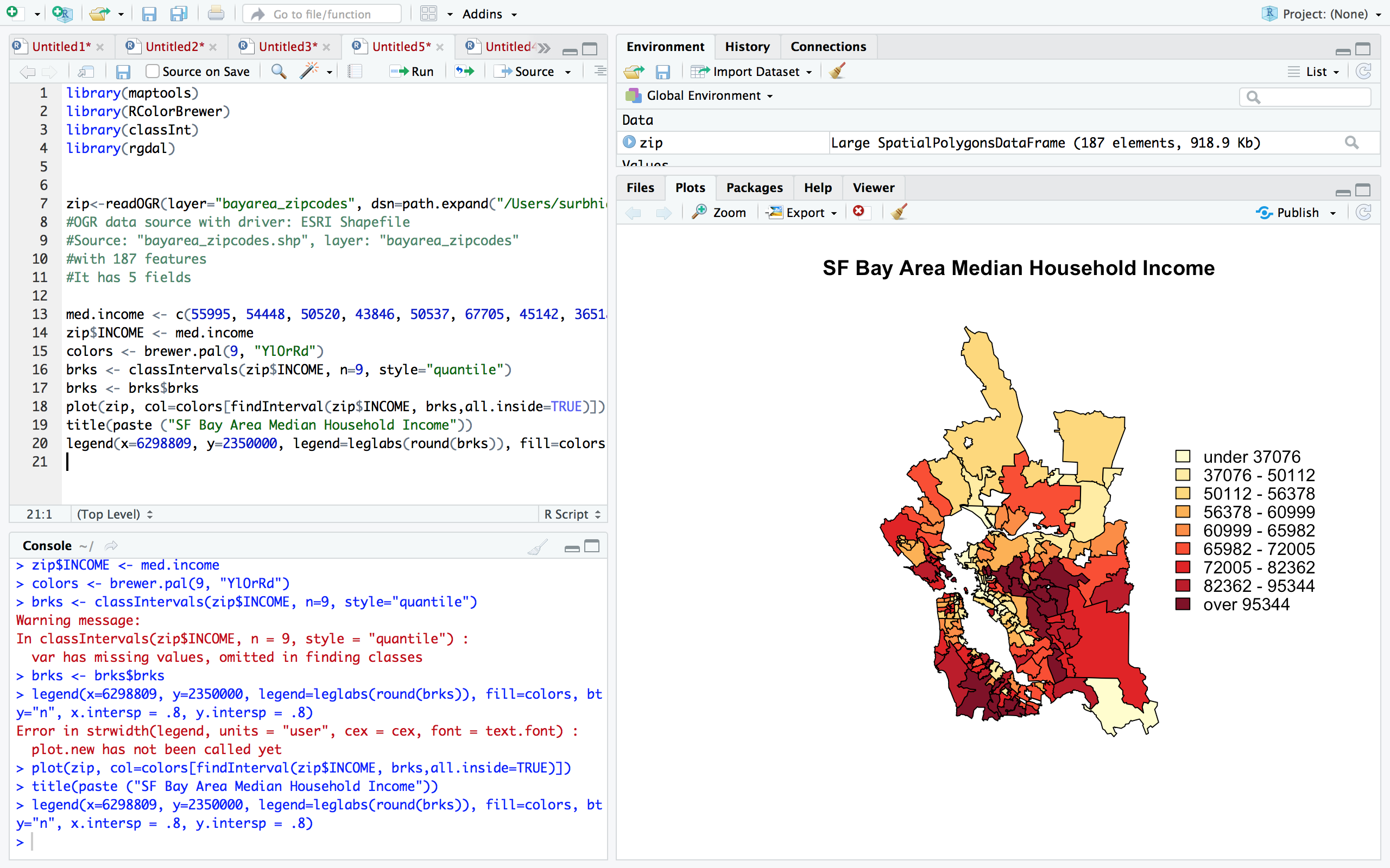

1. Using R run the mtcars examples from the end of the [Tools2](http://www.sci.csueastbay.edu/~esuess/classes/Statistics_6610/viz/viz6/Tools2.html#/) presentations. Show the plots you have created in your homework document.

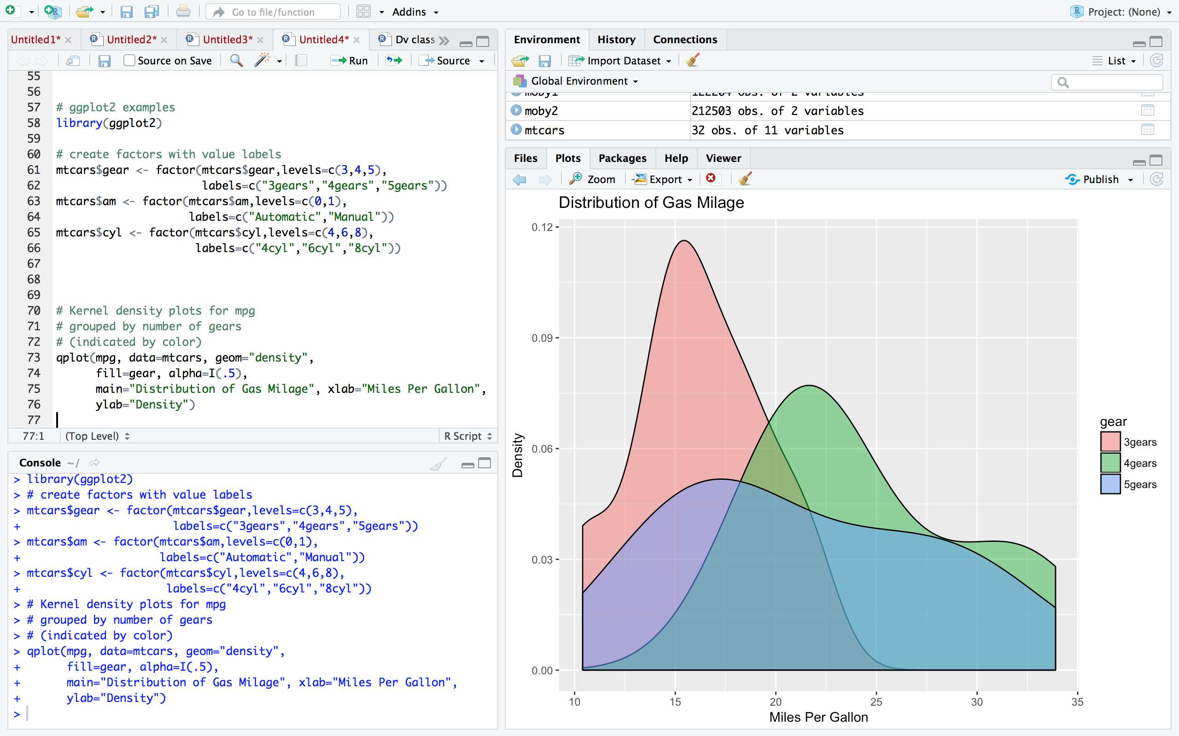

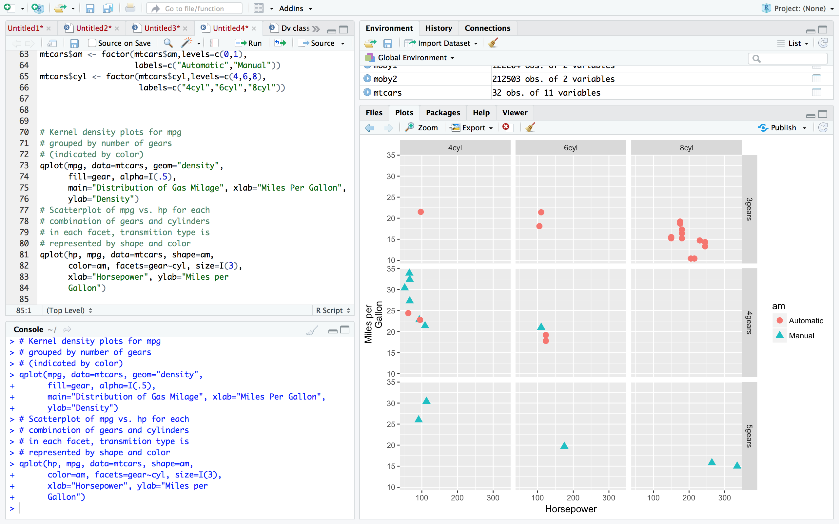

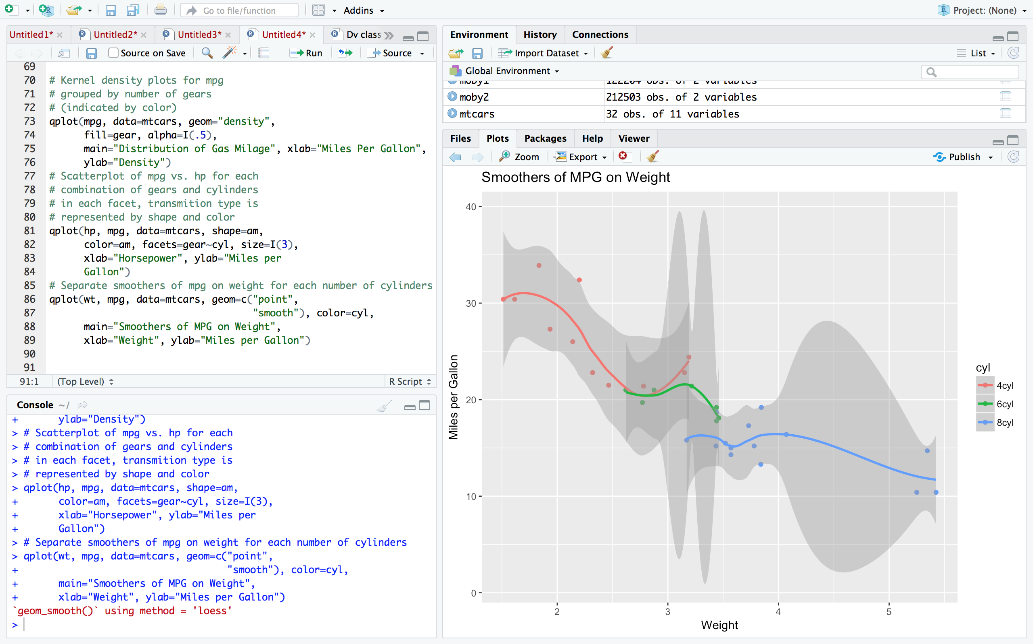

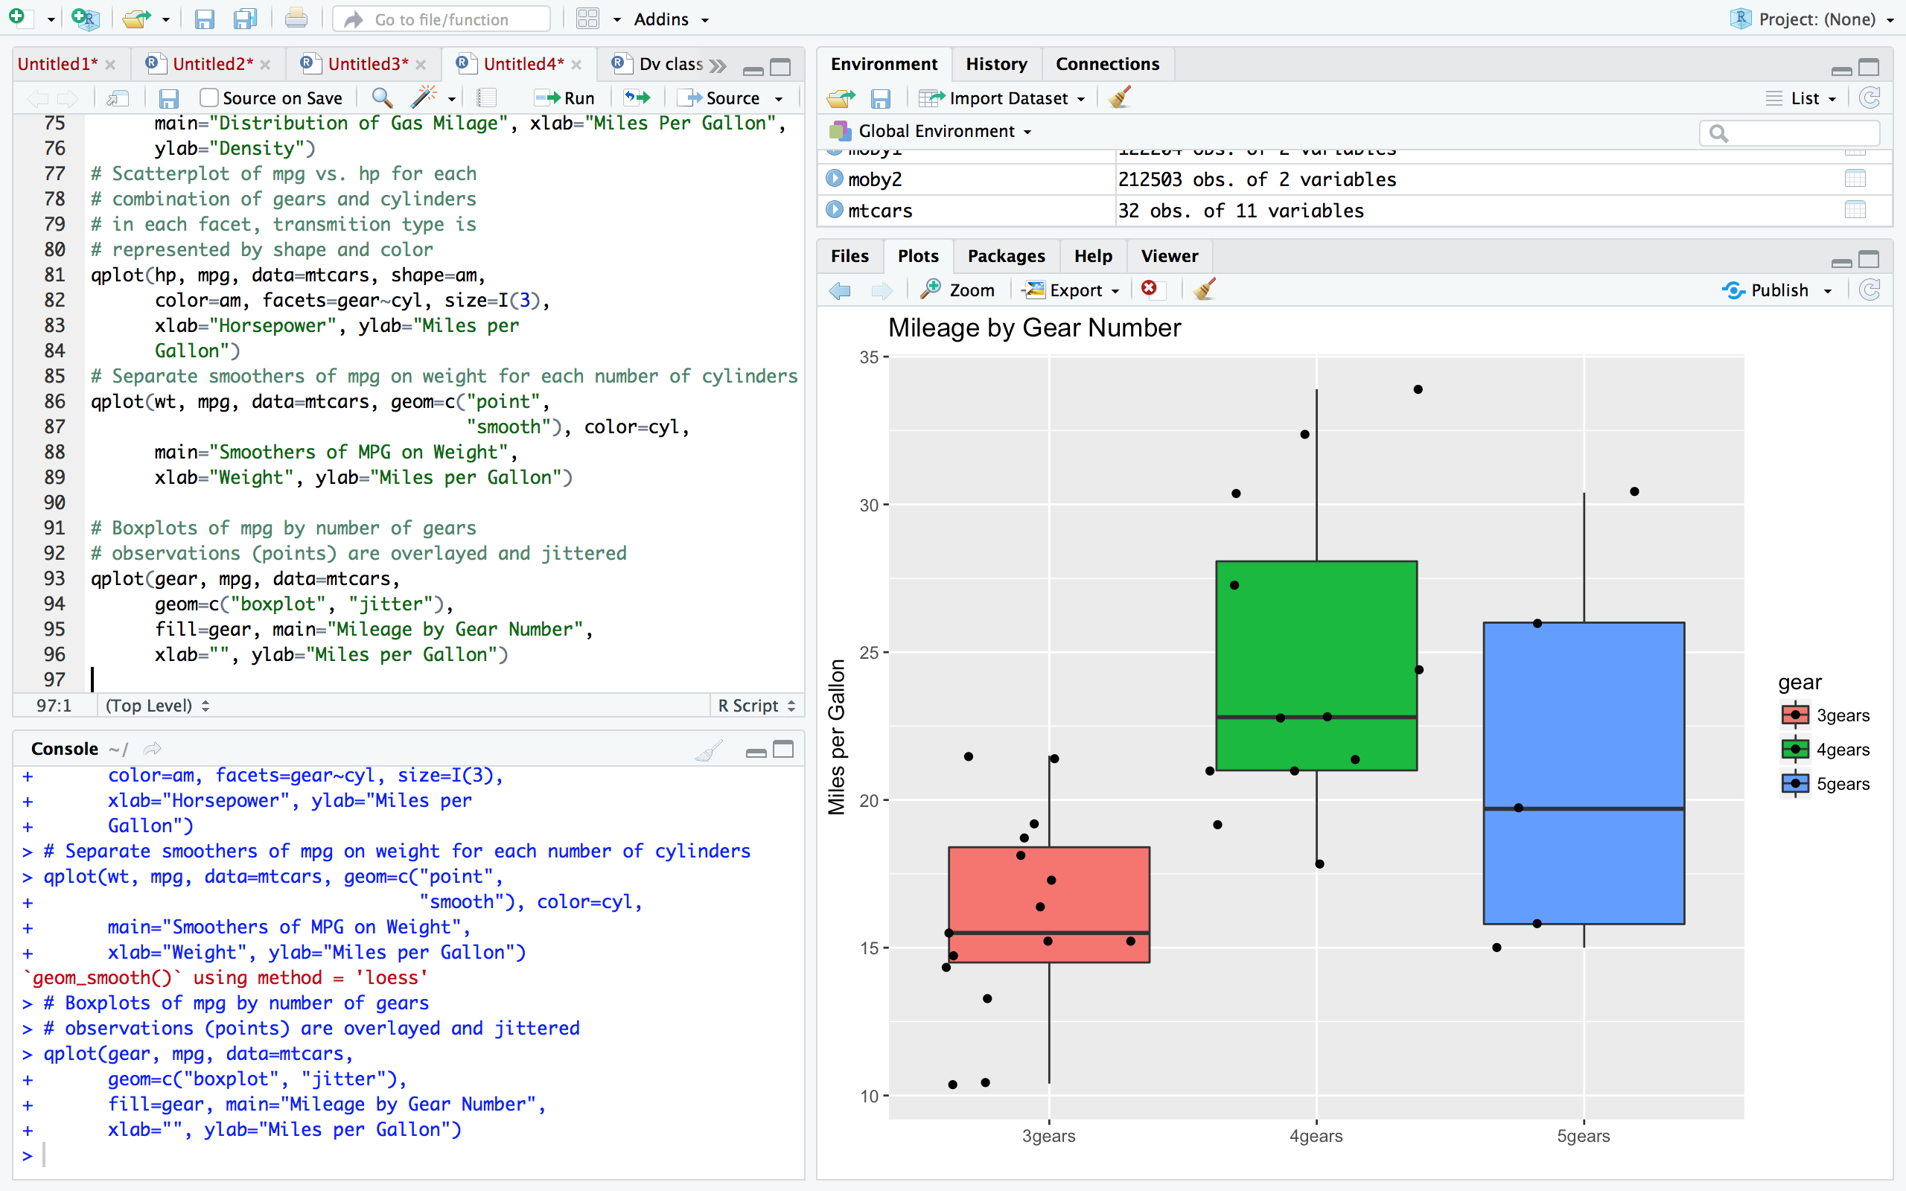

1. From the [Quick-R](http://www.statmethods.net/) website read about working with plots in R. See the [Advanced Graphs](http://www.statmethods.net/advgraphs/index.html) links.
   * [Graphical Parameters](http://www.statmethods.net/advgraphs/parameters.html)

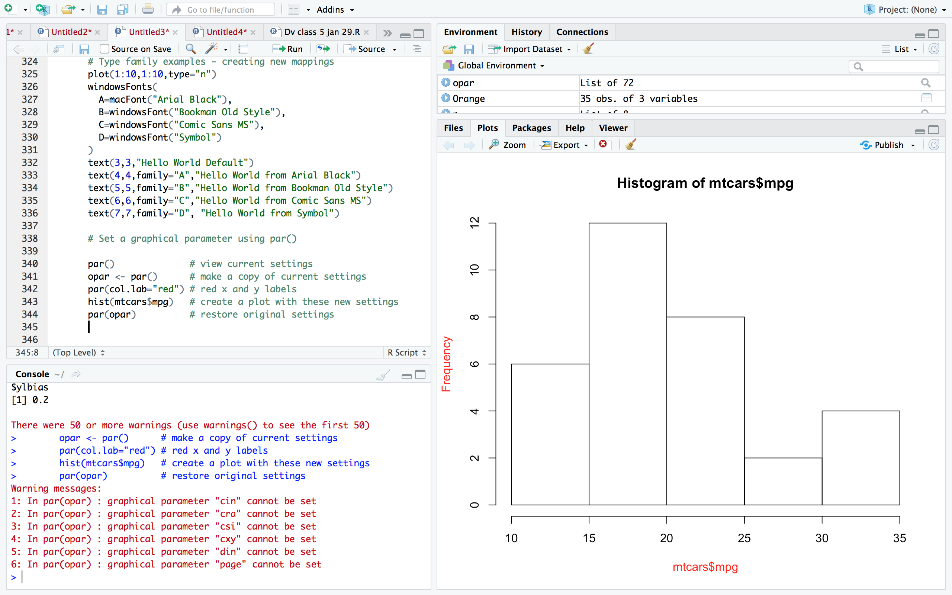

* + [Axes and Text](http://www.statmethods.net/advgraphs/axes.html)

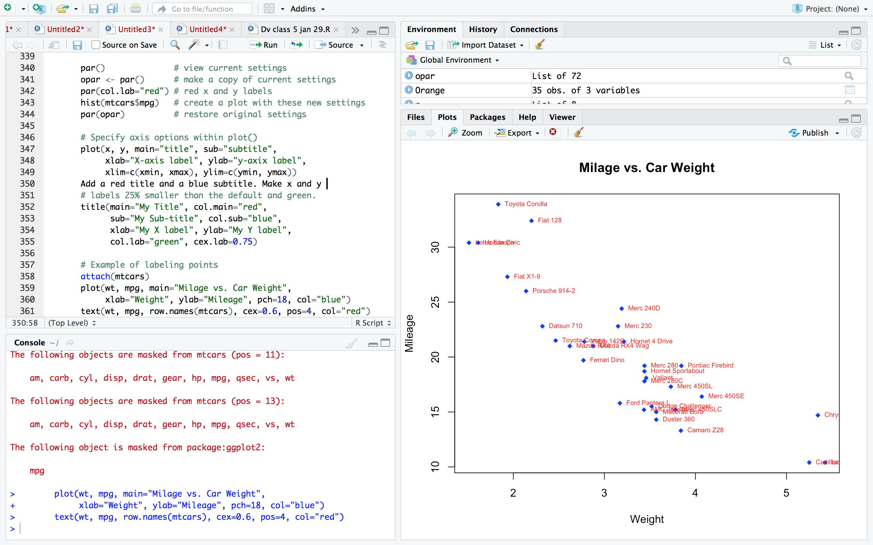

* + [Combining Plots](http://www.statmethods.net/advgraphs/layout.html)

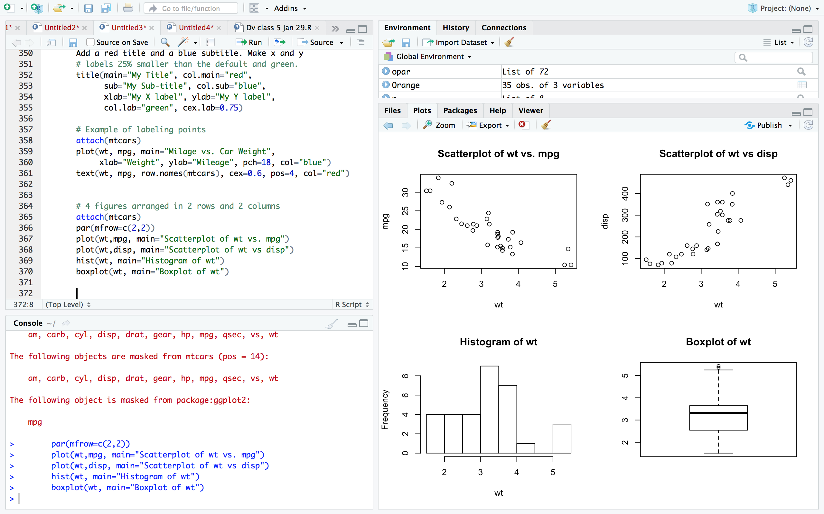

1. From the [Quick-R](http://www.statmethods.net/) website run the R code related to the following topics. See the [Advanced Graphs](http://www.statmethods.net/advgraphs/index.html) links. Show the plots you have created in your homework document.
   * [Lattice Plots](http://www.statmethods.net/advgraphs/trellis.html)

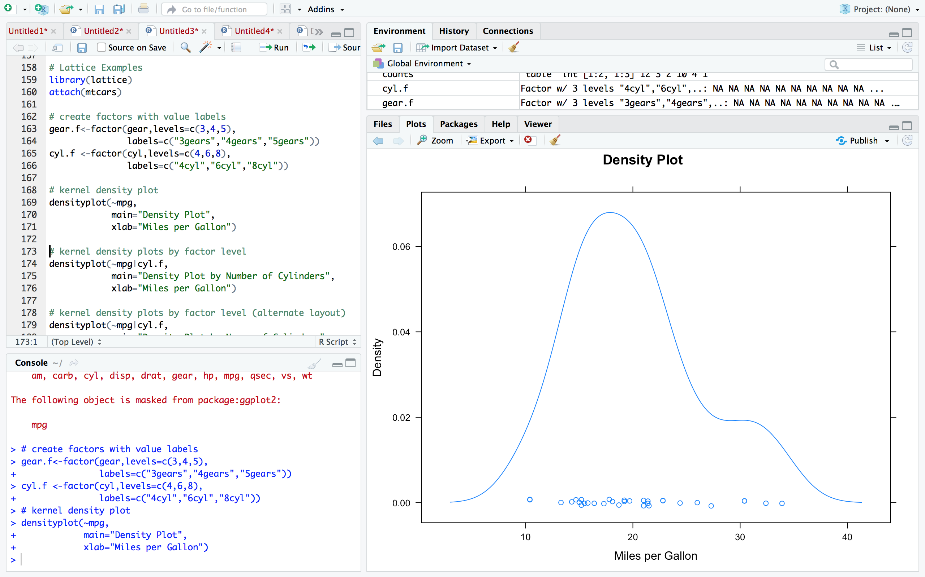

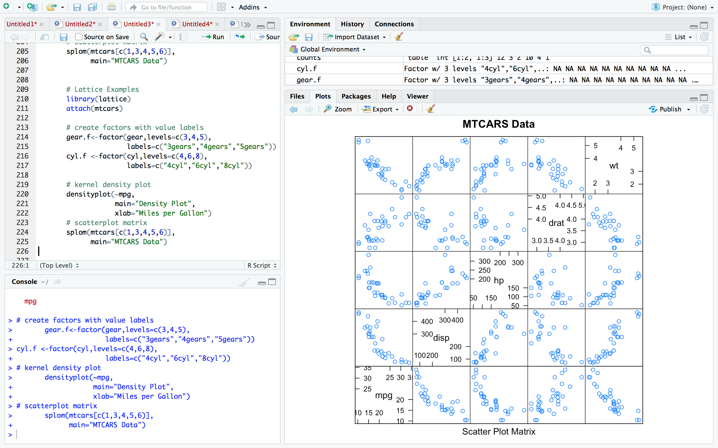

* + [ggplot2](http://www.statmethods.net/advgraphs/ggplot2.html)

Shown in Question 6

* + [Probability Plots](http://www.statmethods.net/advgraphs/probability.html)

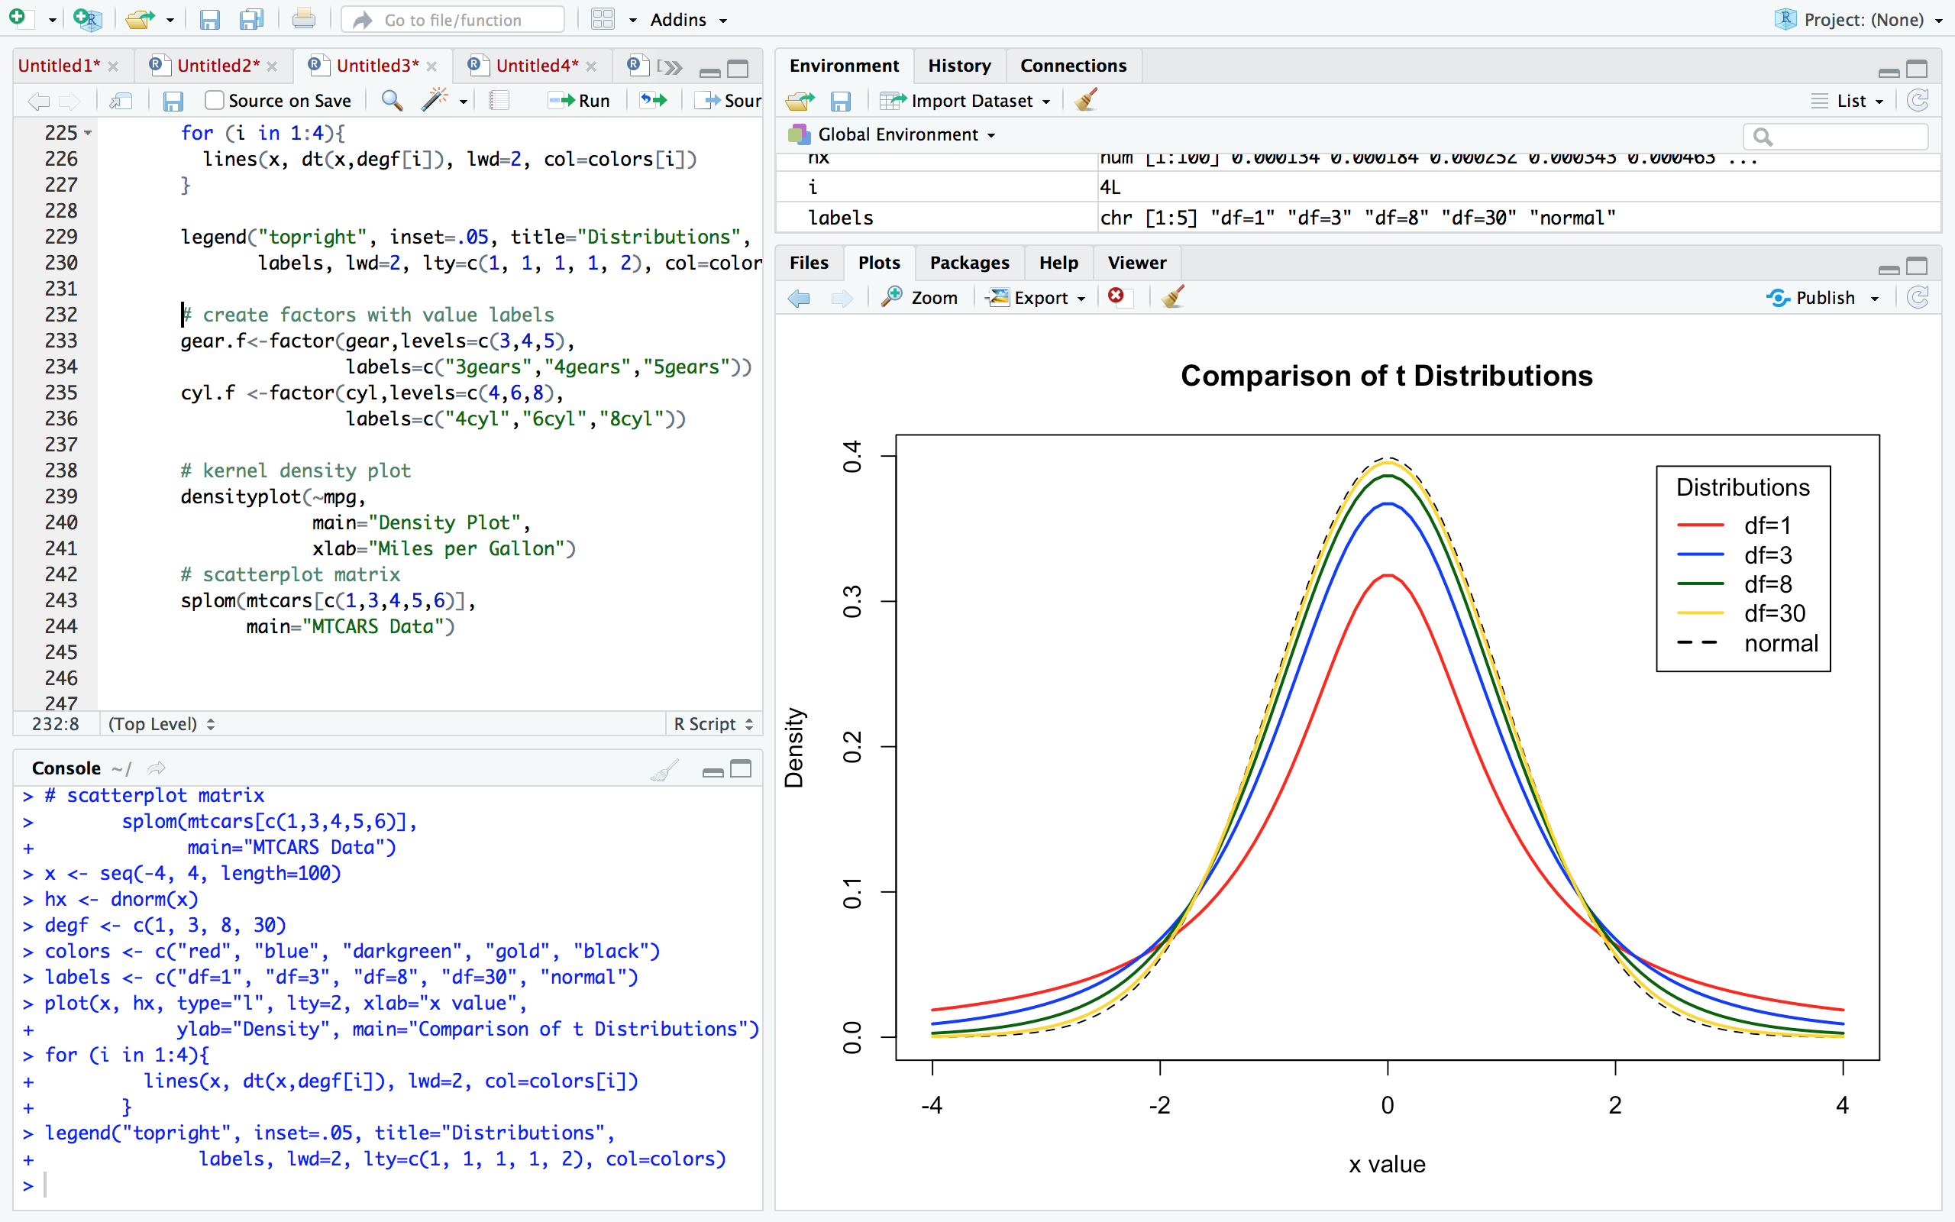

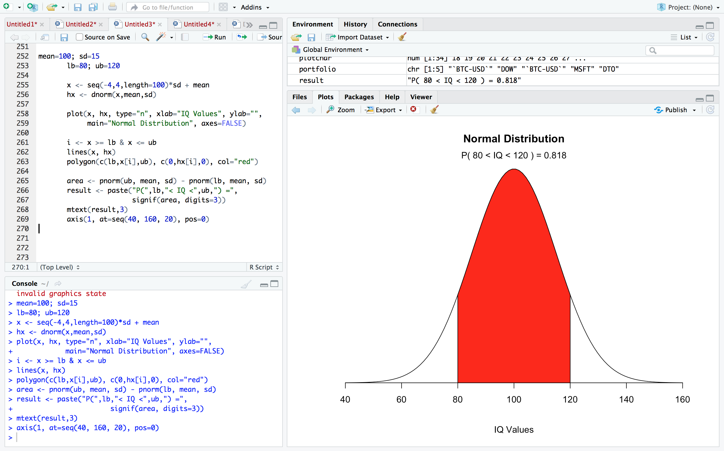

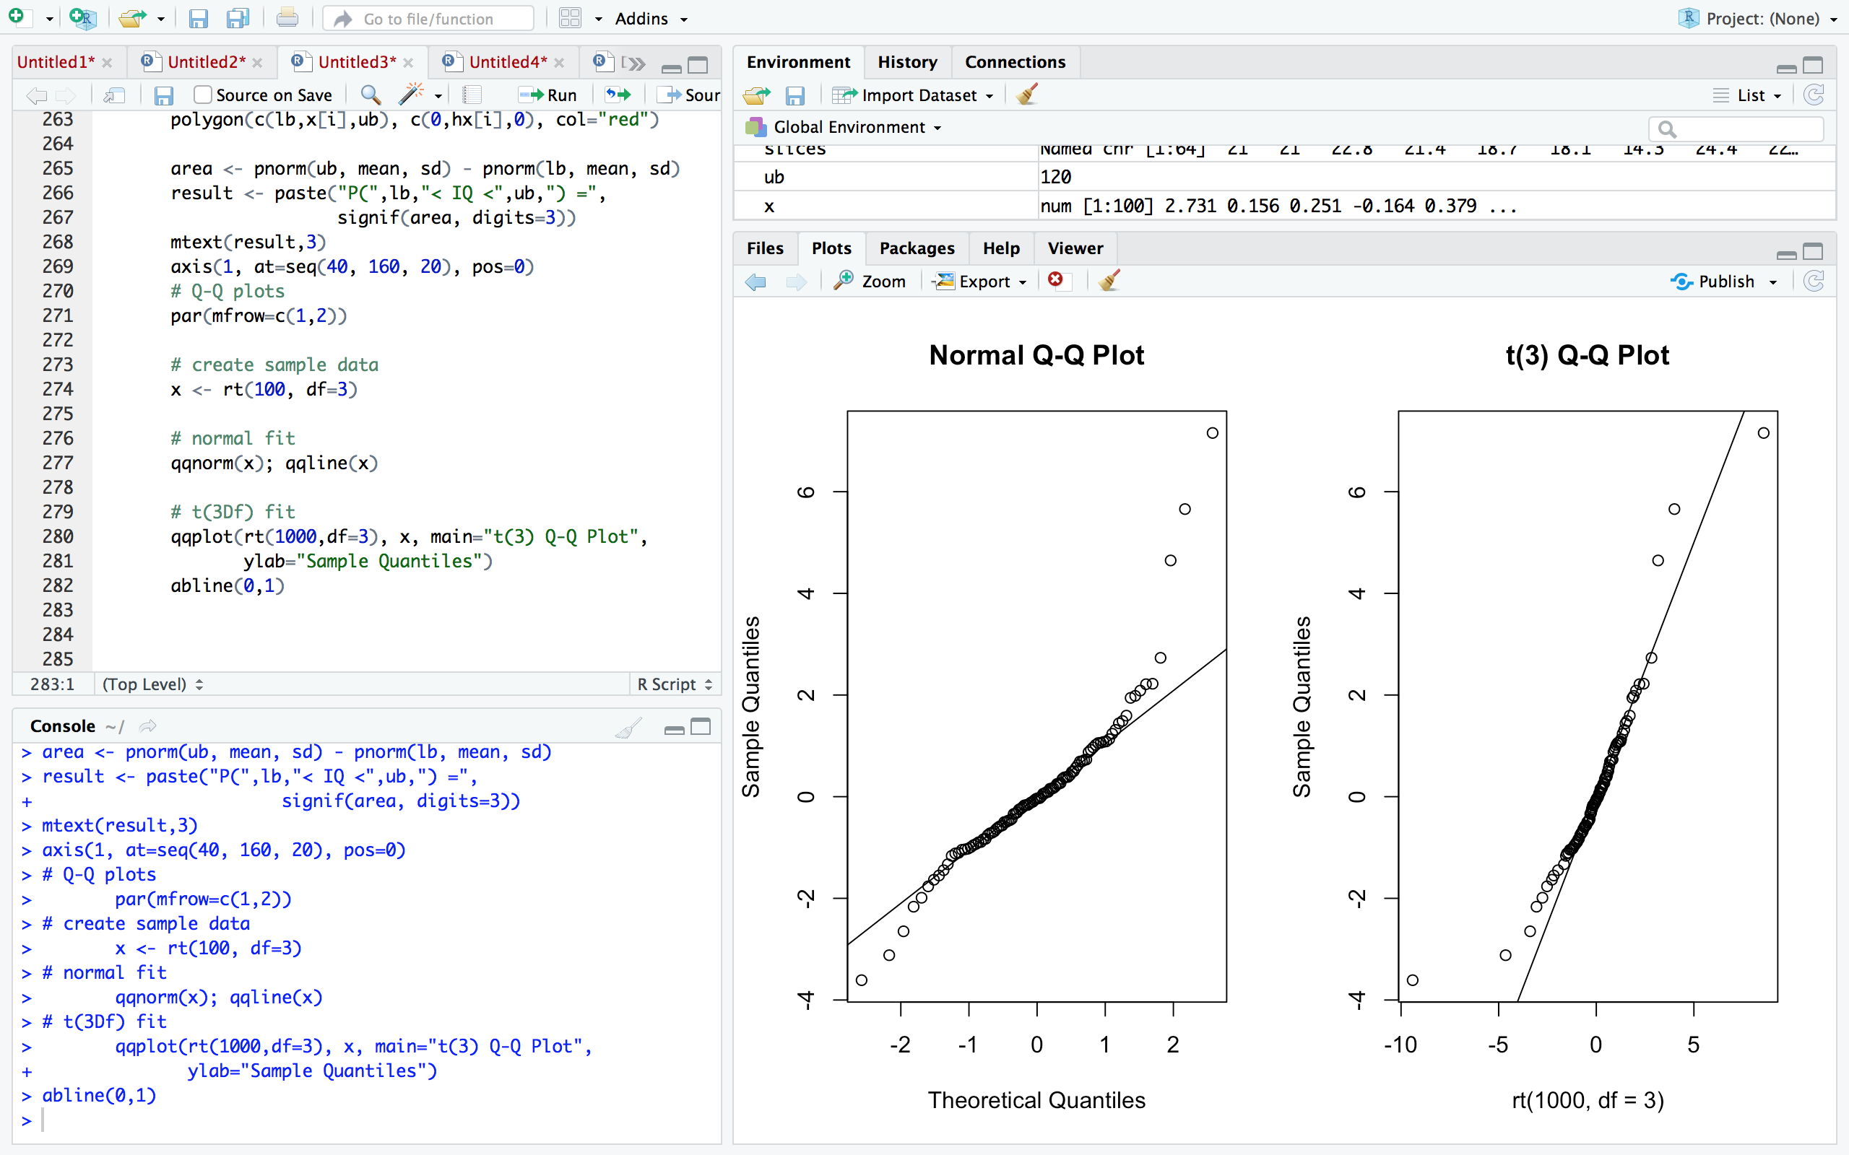

* + [Mosaic Plots](http://www.statmethods.net/advgraphs/mosaic.html)

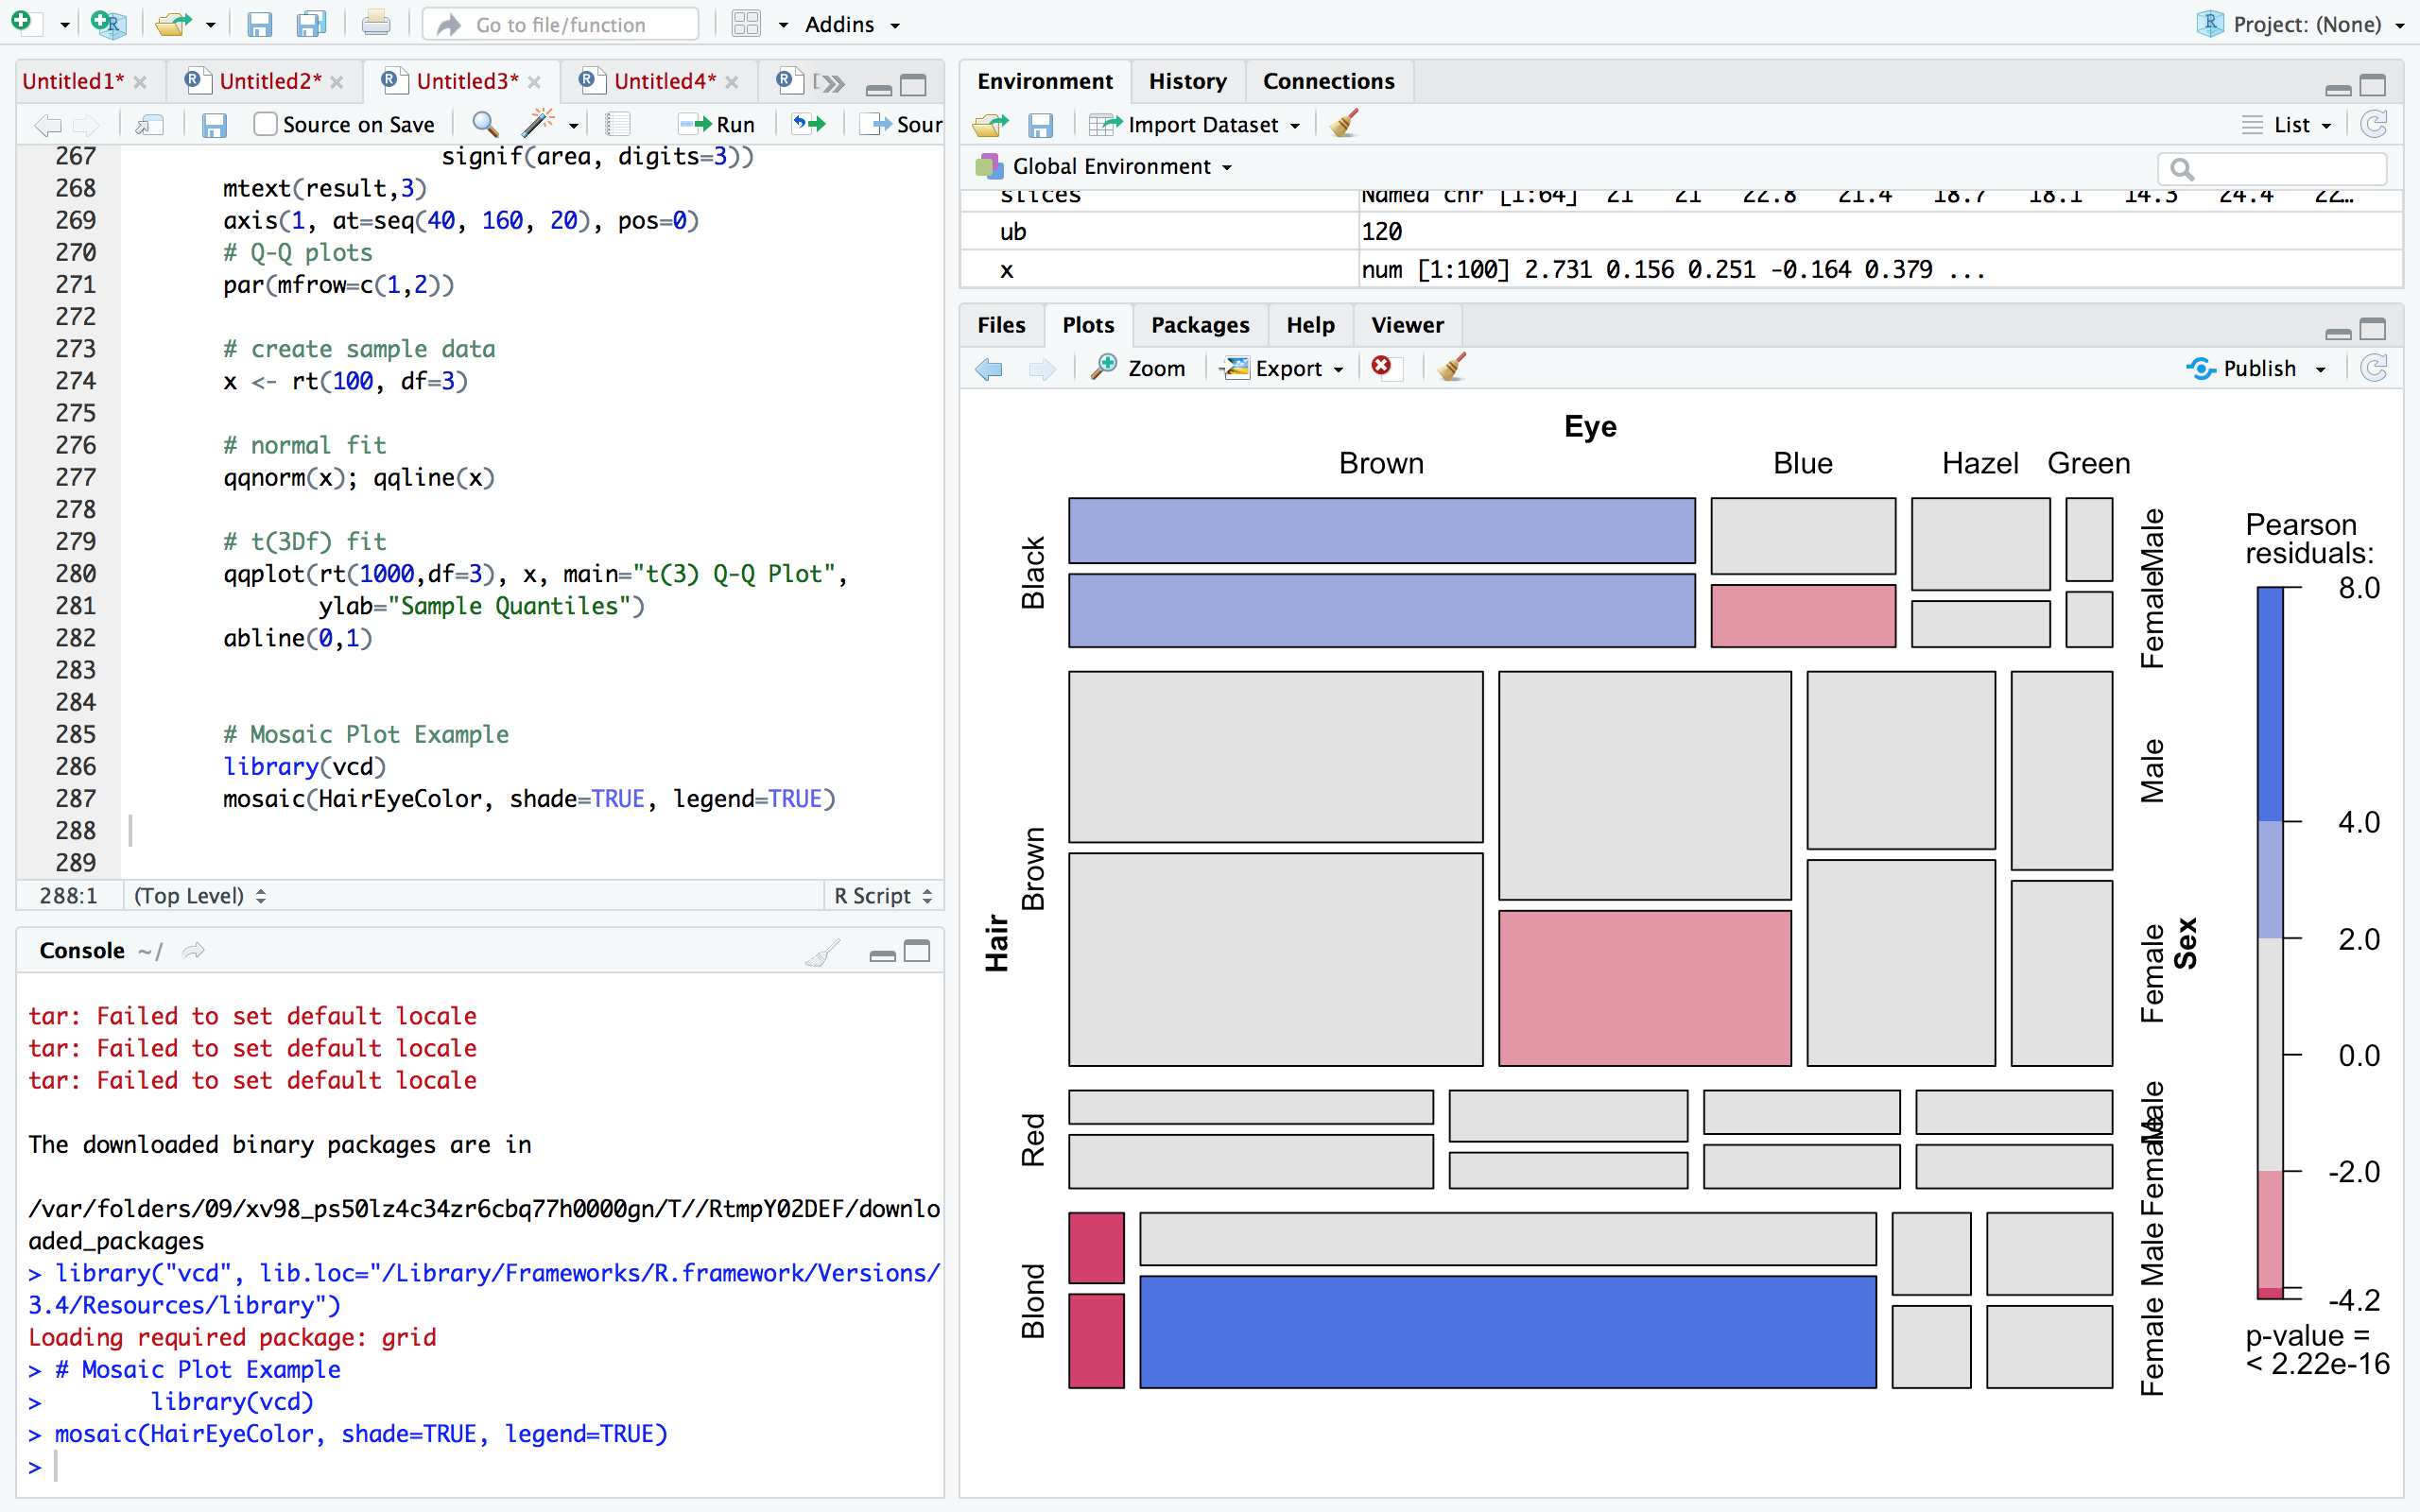

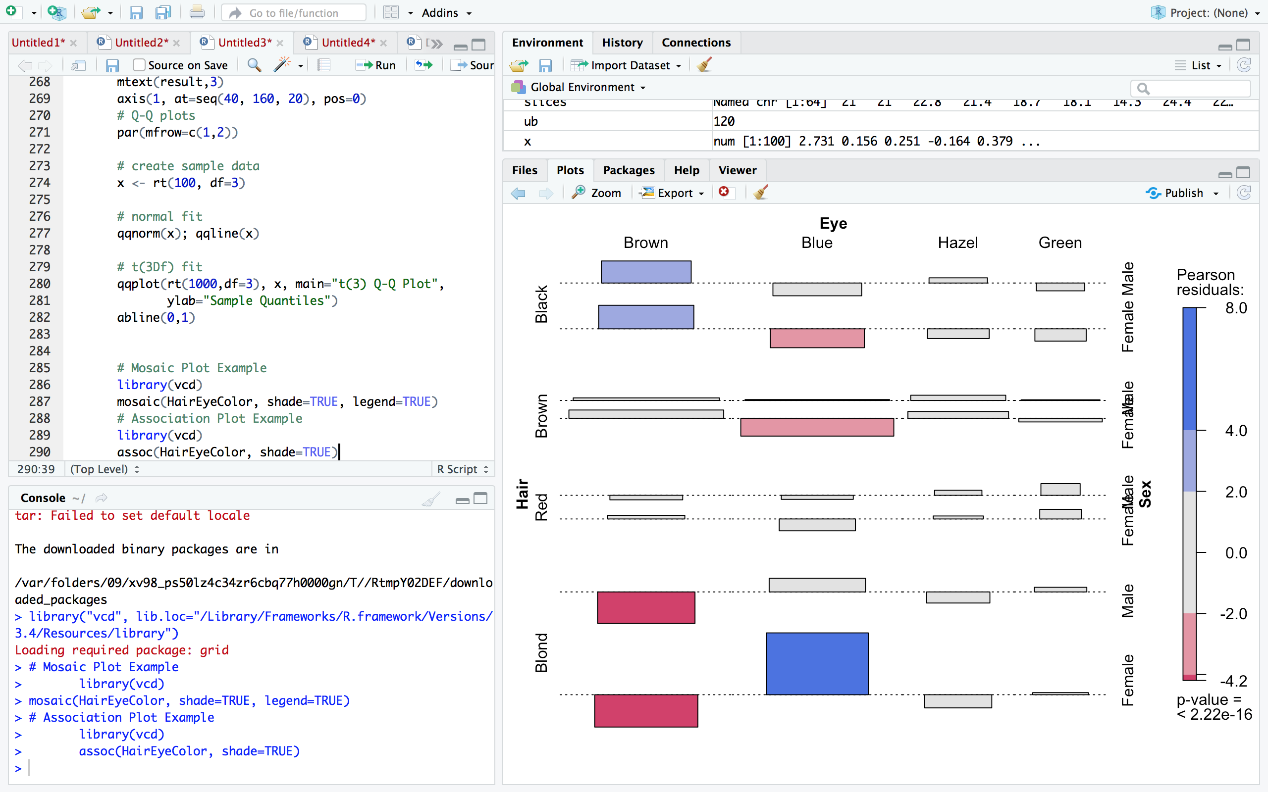

* + [Correlograms](http://www.statmethods.net/advgraphs/correlograms.html)

